**COMSATS University Islamabad,   
Park Road, Chak Shahzad, Islamabad Pakistan**

Project Proposal  
(SCOPE DOCUMENT)

for

**<Banking Bot>**  
Version 1.0

***By***

**Muhammad Usman CU/SP15-BSE-079/ISB**

**Hamza Bhatti CU/FA15-BSE-065/ISB**

***Supervisor*Dr. Sohail Asghar**

*Bachelor of Science in Software Engineering*

|  |  |  |
| --- | --- | --- |
| **No.** | **Comment** | **Action** |
|  |  |  |
|  |  |  |
|  |  |  |
|  |  |  |
|  |  |  |
|  |  |  |

**SCOPE DOCUMENT REVSION HISTORY**

**Supervisor Signature**

**Date:**

**Table of Contents**

Abstract 3

Chatbot is an artificially intelligent virtual assistant that particularly understands the human natural language and responds to their queries accordingly. Our intend is to develop a chatbot for bank that will answer queries related to bank. Banking customers can ask their query in any format and the bot will provide them with possible procedural information. Furthermore, the bot will be able to speak answers as if the real banking receptionist is answering. This banking bot interface will be available on the web, which would provide 24/7 service to increase productivity. 3

1. Introduction 4

2. Problem Statement 4

3. Problem Solution for Proposed System 4

4. Related System Analysis/Literature Review 4

5. Advantages/Benefits of Proposed System 5

6. Scope 5

7. Modules 5

7.1 Module 1: Home Loan Query Processing 5

7.2 Module 2: Car Loan Query Processing 5

7.3 Module 3: Credit and Debit Cards Query Processing 6

7.4 Module 4: Accounts Query Processing 6

7.5 Module 5: Insurance Query Processing 6

7.6 Module 6: Branch Information Query Processing 6

8. System Limitations/Constraints 6

9. Software Process Methodology 6

10. Tools and Technologies 6

11. Project Stakeholders and Roles 7

12. Team Members Individual Tasks/Work Division 8

13. Data Gathering Approach 8

14. Concepts 8

15. Gantt chart 9

16. Mockups 9

17. Conclusion 11

18. References 11

19. Plagiarism Report 11

**Project Category:**

**C-** Problem Solving and Artificial Intelligence

# Abstract

# Chatbot is an artificially intelligent virtual assistant that particularly understands the human natural language and responds to their queries accordingly. Our intend is to develop a chatbot for bank that will answer queries related to bank. Customers can ask information about loans, cards, accounts, Banking customers can ask their query in any format and the bot will provide them with possible procedural information. Furthermore, the bot will be able to speak answers as if the real banking receptionist is answering. This banking bot system will mimic the customer service interface on the web, which would provide 24/7 service to increase productivity.

# Introduction

Today, in Pakistan, almost every person uses a bank. Many newbies found it difficult to know various banking procedures and processes required to avail banking services. The Proposed banking bot system will therefore, first understand user queries in natural language and then provides possible solution of those queries. Furthermore, the bot will be able to understand the human speech and give answers in both text and speech. Unlike current customer service, the bot will be implemented on banking website which would be available anytime almost everywhere. This Scope document primarily discusses the objectives of a proposed system and the tools and techniques used to develop such system. Also, this document will provide the related system analysis, modules used, concepts learned, mockups and the project timeline.

# Problem Statement

Nowadays, in Pakistan, there’s a large population of banking customers. Almost every customer have to visit bank in person to ask certain query. Also, many new customers are having difficulties with many banking procedures. This results in large queues in the banks due to which many customers have to wait for hours. Studies have shown that this waiting time is increasing with the the increasing number of banking customers. Although there are different apps and various platforms provided by the banks, there overwhelming and difficult interface leaves customer with no choice but to visit bank in person. Also, for bank it is time consuming to answer repeated queries. Bank staff get frustrated and their work tensions increases. Moreover, extra manpower resource and inquiry counter is required to deal the customers.

# Problem Solution for Proposed System

The proposed system is a banking bot, developed using artificial intelligence algorithms that analyses user’s queries and understand user’s message. This system is to be developed for the banks where users can ask any banking related questions like loan policy, mortgaging plans, account information, cards, insurance planes and etc. Unlike the other system, users does not have to follow standard format while asking any queries. Just like human operator, the bot will understand human speech and answer the query in both, speech and text based output. Due to the ubiquitous nature of web, this bot will be implemented on bank website which is available to everyone just everywhere. Furthermore, it will increase productivity by giving 24/7 service to the customers.

# Related System Analysis/Literature Review

Table 1Related System Analysis with proposed project solution

|  |  |  |
| --- | --- | --- |
| **Application Name** | **Weakness** | **Targeted Project Solution** |
| HSBC Banking bot | * Answer standard queries * Relatively slower output * Provides only text based output. | * Does not follow standard format. Thanks to Natural language Processing. * Relatively faster * Provides both speech and text based output. |
| HBL Mobile app | * Relatively slower output | * Relatively faster. Thanks to machine learning classification algorithms |
|  | * Doesn’t provide solutions to queries related to insurance, loans and mortgaging plans. |  |

# Advantages/Benefits of Proposed System

* System will understand natural language and provide possible answers related to bank.
* System will take input in both text and speech.
* System will be available 24/7 for customer assistance.
* System will be available everywhere. User don’t have to visit bank in person.
* System will also be provide speech based output as if real human is answering.
* System will also provide the print of chat logs.

# Scope

The proposed system is an artificially intelligent bot designed for a particular bank for eg (HBL). This system analyze and understands human language and responds according to their query. There is no specific format of asking a query. Customer can ask questions related to various bank activities like loans, mortgaging, accounts, credit and debit cards, branch information and security. Also, this bot can take input and provide output in both speech and text format as if conversation is taking place between customer and banking staff. This chatbot will be implemented on the bank website which available to every bank customer. This software will also incorporate the changes in bank policies

# Modules

## Module 1: Home Loan Query Processing

This module lets user asks queries related to home loan in both speech and text format. Using natural language processing and deep learning algorithms the system will intelligently understand user statement and provide the possible procedures.

## Module 2: Car Loan Query Processing

This module lets user asks queries related to car loan in both speech and text format. Using natural language processing and deep learning algorithms the system will intelligently understand user statement and provide the possible procedures.

## Module 3: Credit and Debit Cards Query Processing

This module lets user asks queries related to Credit and debit cards in both speech and text format. Using natural language processing and deep learning algorithms the system will intelligently understand user statement and provide the possible procedures.

## Module 4: Accounts Query Processing

This module lets user asks queries related to Accounts in both speech and text format. Using natural language processing and deep learning algorithms the system will intelligently understand user statement and provide the possible procedures.

## Module 5: Insurance Query Processing

This module lets user asks queries related to Insurance in both speech and text format. Using natural language processing and deep learning algorithms the system will intelligently understand user statement and provide the possible procedures.

## Module 6: Branch Information Query Processing

This module lets user asks queries related to branch information in both speech and text format. Using natural language processing and deep learning algorithms the system will intelligently understand user statement and provide the possible procedures.

# System Limitations/Constraints

Requires 1MB/s internet connection

Requires user authentication.

# Software Process Methodology

The selected software process for the proposed system is agile method. In agile method each module is developed in the form of small increments. The rationale behind using agile methodology for this system is to anticipate changes without making huge modifications to schedule. Secondly, this process methodology entails breaking down project into prioritized requirements. This means we can develop and test the requirement with the highest priority first.

# Tools and Technologies

|  |  |
| --- | --- |
| **Tools** | **Rationale** |
| Spyder | Python IDE |
| Notepad ++ | Editor |
| Pycharm | Python IDE |
| Anaconda | Python Package Manager |
| MySQL | Database Manager |
| Adobe Photoshop | Mockup Designing |
| MS Powerpoint | Presentation |
| Jupyter Notebook | Sharing live codes |
| Natural Language Toolkit | Natural language Processing |
| MS Word | Word Editor |
| MS Excel | Graphing tool |

|  |  |
| --- | --- |
| **Technologies** | **Rationale** |
| Python | Deep Learning, Web services, Natural language Processing |
| SQL | Database Query language |
| Javascript | Webdesign |
|  |  |
|  |  |
|  |  |

|  |  |
| --- | --- |
| **Libraries** | **Rationale** |
| Tensorflow | Machine Learning |
| Django | Python Web Framework |
| Angulat Js | Javascript library |
| SpaCy | Natural language Processing library |
| Sci-kit | Machine learning |

# Project Stakeholders and Roles

Write down the project stakeholders and their roles.

Table 3Project Stakeholders for Proposed Project

|  |  |
| --- | --- |
| **Project Sponsor** | COMSATS University, Islamabad |
| **Stakeholder** | Mr. Muhammad Usman  Mr. Humza Bhatti  Supervisor: Dr. Sohail Asghar |

# Team Members Individual Tasks/Work Division

Table 4Team Member Work Division for Proposed Project

|  |  |  |
| --- | --- | --- |
| **Student Name** | **Student Registration Number** | **Responsibility/ Modules** |
| Muhammad Usman | SP15-BSE-079 | Mr. Usman (Module1-Module2-Module3)  Queries regarding loans and cards. |
| Humza Bhatti | FA15-BSE-065 | Mr.Humza(Module4-Module5-Module6) |

# Data Gathering Approach

Data gathering approaches used:

Observation

We observe banking customers asking queries with the bank operator in real time. Their needs and expectations are observed.

Interview

We have conducted an interview with HBL bank manager. We’ve asked him about the procedures and functions that bank perform.

# Concepts

**Natural Language Processing**

Natural language processing is a part of computer science and artificial intelligence that deals with human interactions with the computer in natural language. In this particular project, natural language processing is used extensively for pre-processing and feature extraction.

**Deep Learning**

Deep learning is the part of machine learning that make machine artificially intelligent to achieve different tasks. In this project, we use deep learning sequence to sequence models to encode and decode user input.

**Web services with Python**

During development, we learned different concepts about Django framework and restful api.

# Gantt chart

Create the Grant Chart and provide estimated start and end dates of all proposed modules/tasks for each team member. Also identify the dependencies (which tasks cannot be started/completed, until the dependent task is completed). Gantt chart can be created using MS Project.

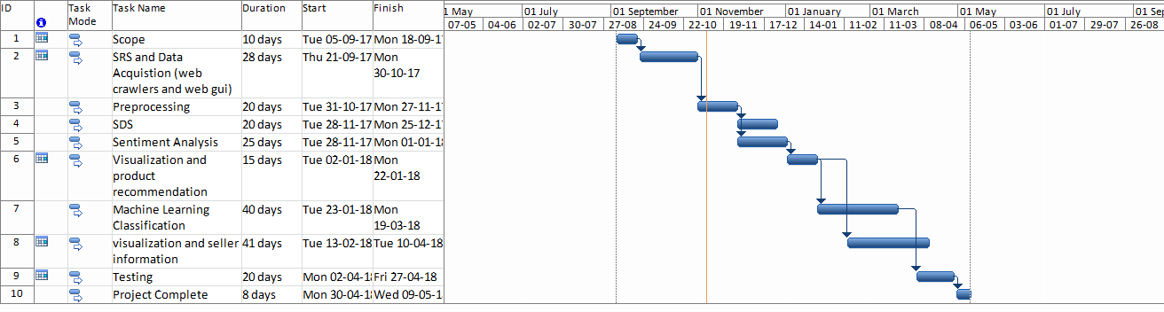

Figure 1Sample Gantt chart

# Mockups

Insert minimum mockups (Usually 4-6 mockups) which show the major modules mentioned in the scope section of the document. Do not include mockups for Login, Signup, Forgot Password, Contact Us, About Us etc. If the project is a Web or a Smartphone Application, then include at-least three mockups from each part of the project. You can design mockup in any design tool for example pencil tool (<https://pencil.evolus.vn/>) or Balsamiq (<https://balsamiq.com/>)

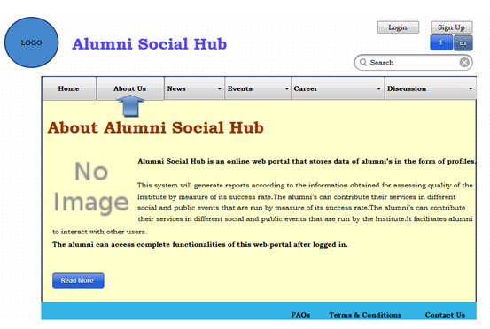

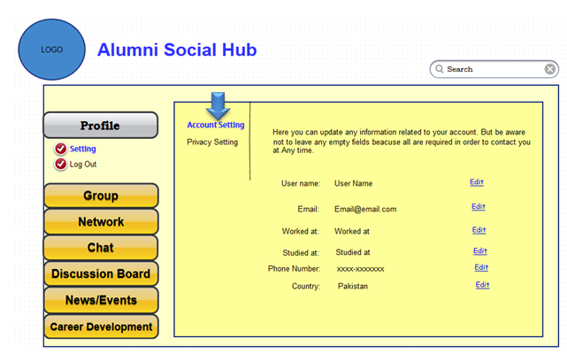

# Conclusion

Conclude this document.(Usually 4-5 sentences)

# References

Mention the books, research papers, web links etc.

# Plagiarism Report

Attach the Plagiarism report of your project scope document from library staff of turnitin tool (<http://turnitin.com>)